
Coimbatore

19/05/2026

21/05/2025 to 20/05/2035
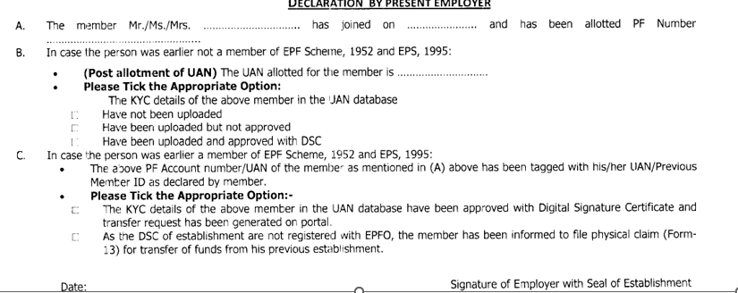AB592978

ILGPP2150D
883975863964
500101010488103, CIUB0000078
No
Yes
- perumal.palaniappan04@gmail.com
- 8838375900
Unmarried
Male
26/02/2004
Palaniappan S
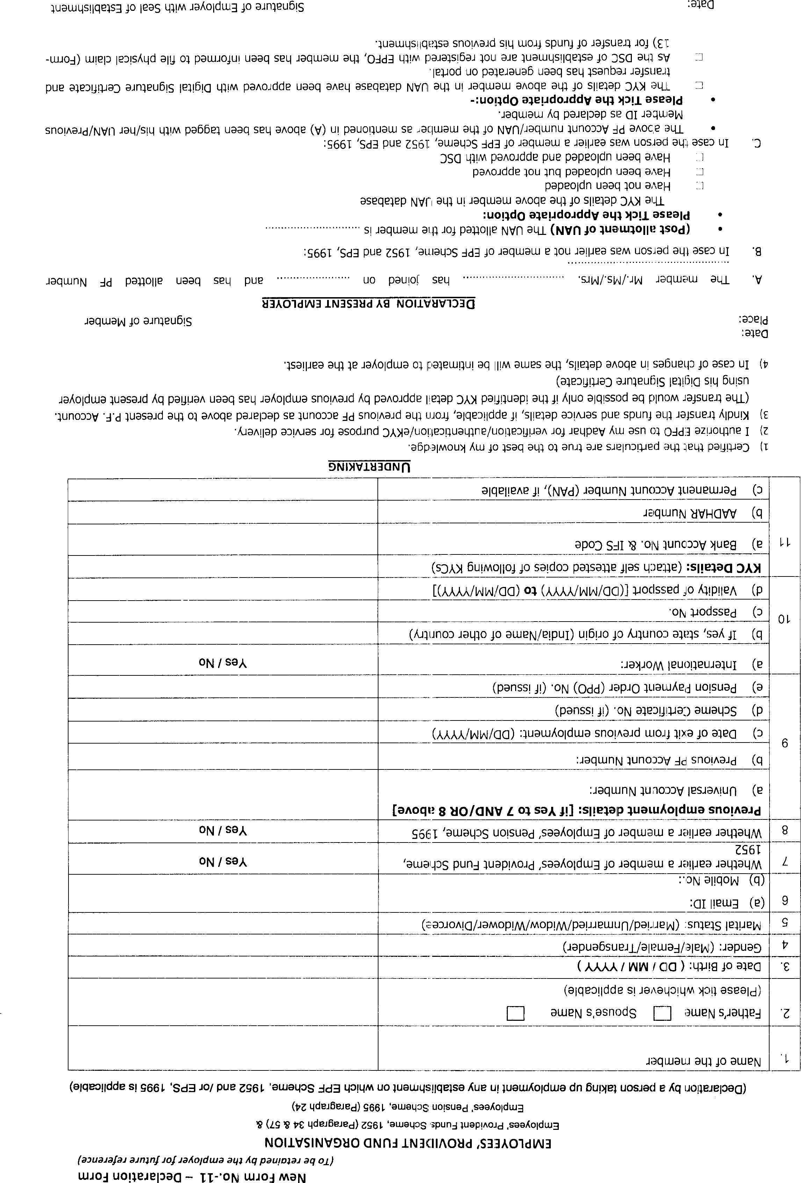
102337478261
Perumal P

